# 1) REGISTER

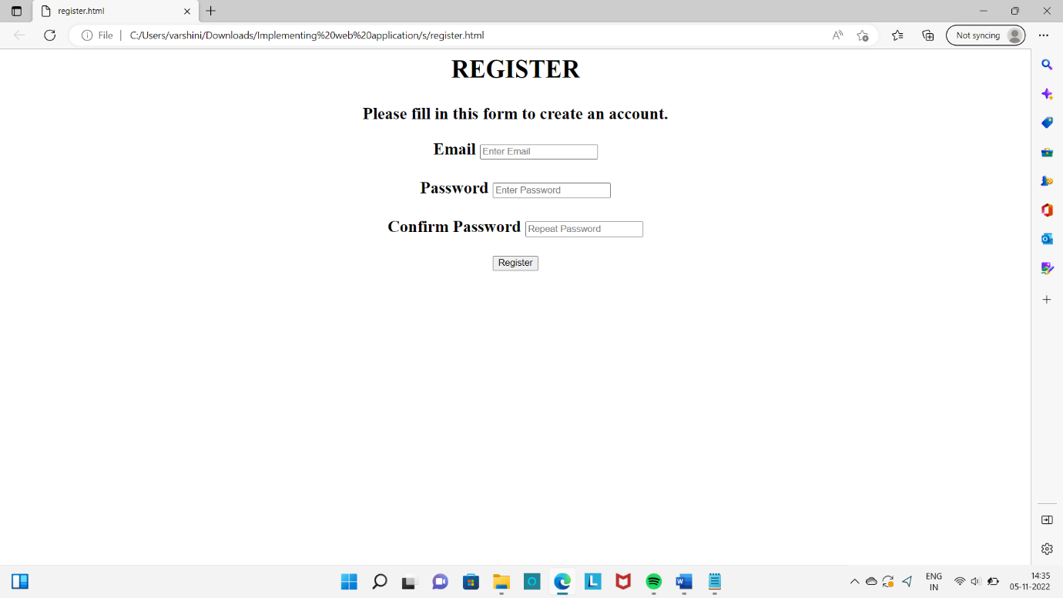

**PREDICTION RESULTS PAGE FOR FOOD ITEM**

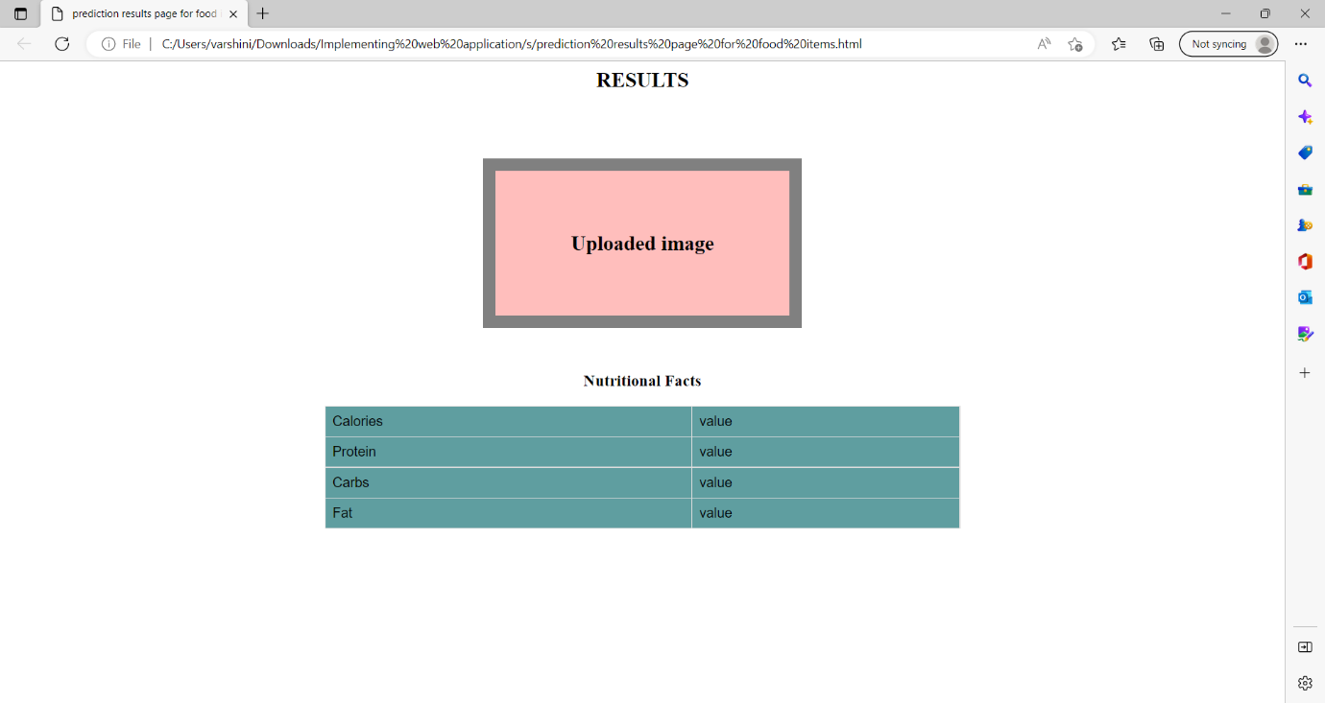

**UPLOAD IMAGE**

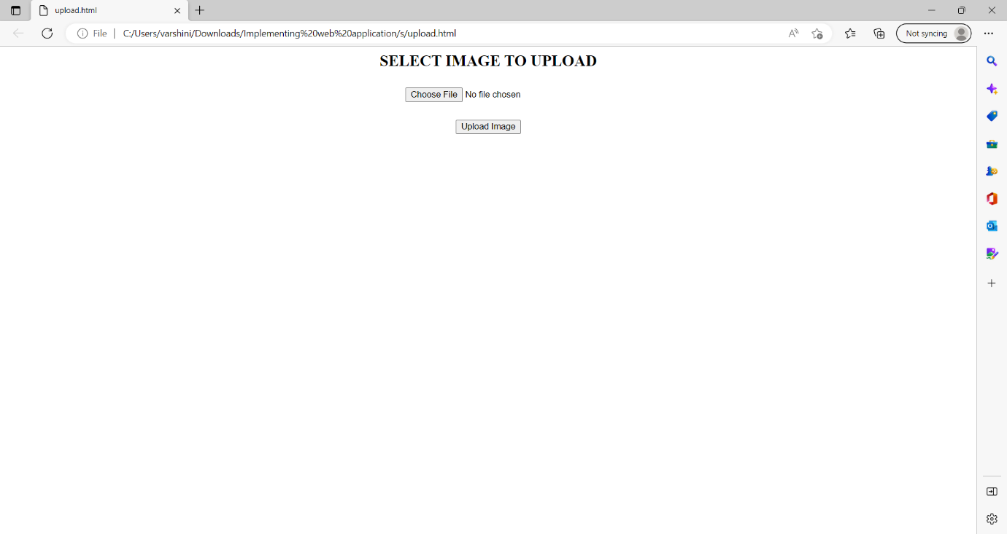

**PREDICTION RESULTS PAGE FOR FOOD ITEMS**

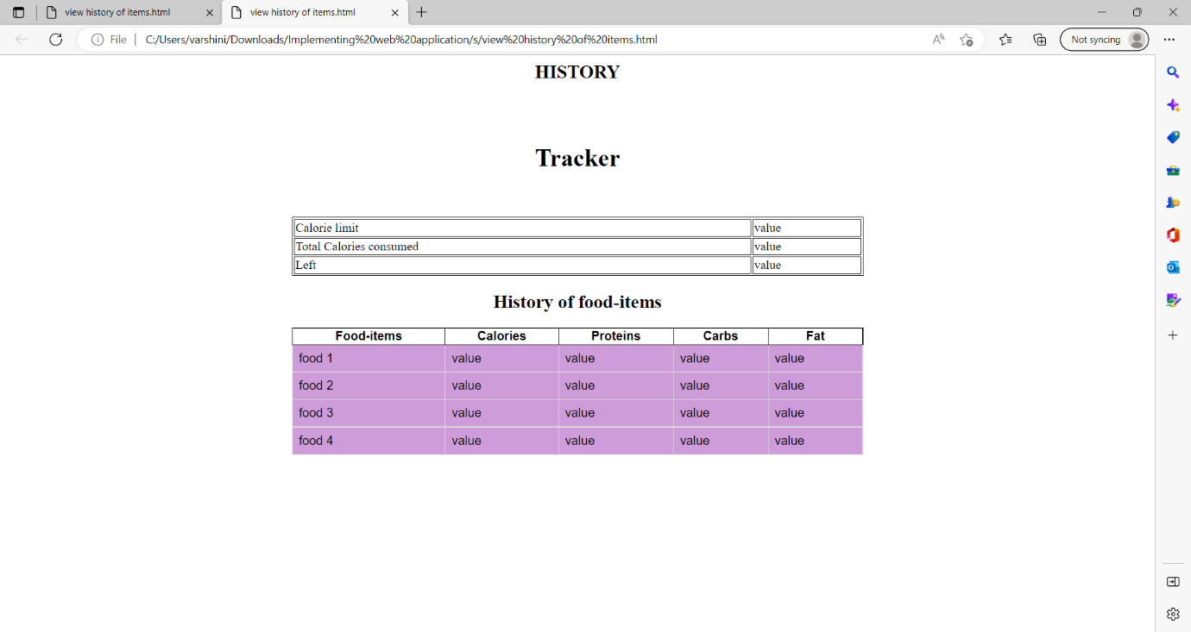

**LOGIN**

